**Project Overview**

**Purpose of Project**

* To examine if AMP effects are moderated by awareness of the prime’s influence on one’s target evaluations.

**Description of the Experiments**

Below is a visual illustration of the structure adopted in Experiments 1-8

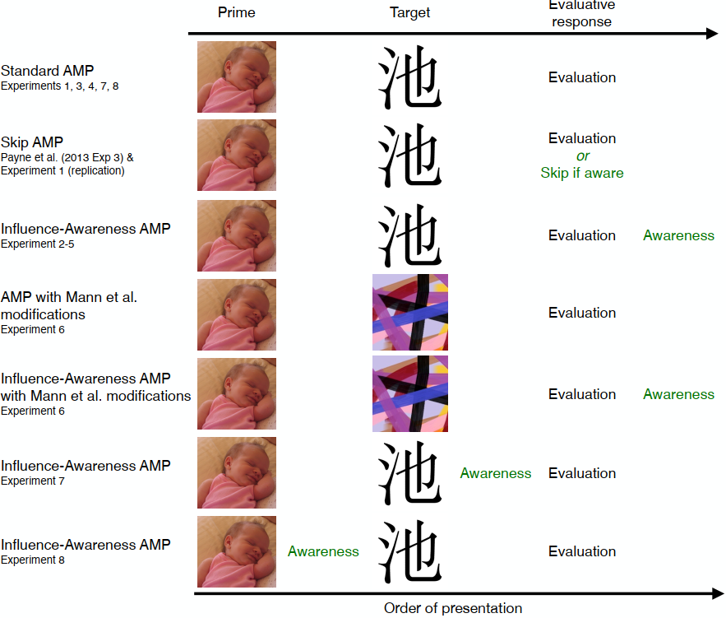

**Links to OSF**

Archived files for distribution available on the OSF: [osf.io/gv7cm](<https://www.osf.io/gv7cm>)

**Current Status of Manuscript**

* Under review at *Behavioral Research Methods*